WEB ROUTING

USER MANUAL

SLIPPERY ROCK UNIVERSITY

Alex Dickson acd1015@sru.edu

Thomas Haley tjh1019@sru.edu

Sinchana Kori ssk1002@sru.edu

Beth Orgovan bro0700@sru.edu

Dakota Myers drm1022@sru.edu

Table of Contents

### 1. Getting Started – Home Page and Navigation 4

### 2. Login and Users 5

### 2.1 Registration 5

### 2.1.1 shipper account Registration 6

### 2.1.2 Carrier Account Registration 7

### 2.2 Roles 8

### 2.3 Users 9

### 2.3.1 Add User 9

### 2.3.2 Update User 11

### 2.4 Updating User Details 11

### 3. contacts 13

### 3.1 Add Contact 13

### 3.2 Edit Contact 14

### 3.3 Delete contact 15

### 4. Location 15

### 4.1 Add Location 15

### 4.2 Edit Location 16

### 4.3 Delete Location 16

### 5. Vehicles 17

### 5.1 Add vehicle 18

### 5.2 Edit vehicle 19

### 5.3 Delete Vehicle 19

### 6. Vehicle Types 19

### 6.1 Add Vehicle Types 19

### 6.2 Edit Vehicle Types 20

### 6.3 Delete Vehicle Types 20

### 7. Drivers 21

### 7.1 Add Driver 21

### 7.2 Edit Driver 22

### 7.3 Delete Driver 22

### 8. Technicians 22

### 8.1 Add Technician 23

### 8.2 Edit Technician 24

### 8.3 Delete Technician 24 9. Maintenance Orders 24

### 9.1 Add Maintenance ORder 25

### 9.2 Edit Maintenance Order 26

### 9.3 Delete Maintenance Order 26

### 10. Carriers 26

### 10.1 Details on Adding Carriers 27

### 10.2 Edit Carrier 28

### 11. Shipments and Bids 28

### 11.1 Shipments Overview 29

### 11.2 Shipments – SHIPPER 30

### 11.2.1 Created Shipments - Shipper 30

### 11.2.2 Upload excel file - shipper 32

### 11.2.3 accepted shipments - shipper 32

### 11.2.4 view / accept bids - shipper 33

### 11.3 shipments – carrier 34

### 11.3.1 Created shipments - carrier 34

### 11.3.2 Place/edit Bids - carrier 35

### 11.3.3 Accepted Shipments - carrier 36

### 11.4 Shipments – Master List 38

### 12. Routes 41

### 13. Logs 45

### 14. Notifications 46

### 15. DataBase 47

### 16. EXCEL UPLOADING 48

### 17. Figures 49

# 1. Getting started – Home PAge and Navigation

Upon program launch, the user is greeted by the System home page (**Figure 1**). The user has the option to navigate to either the log in page or the account registration page.

The side navigation bar (**Figure 1 - on left**) will present different options pertaining to the user’s role and is available across the website. It is collapsible via the ‘  ’ button in the top right of the bar. The navigation bar can be expanded by clicking the ‘  ‘ button (**Figure 2 - on left)**

**Figure 1 – Home Page of System (Content-Push Nav-Bar Open)**

**Figure 2 – Home Page of System (Content-Push Nav-Bar Closed)**

# 2. Login and users

A fresh installation of the program comes with the following default role accounts preinstalled:

|  |  |  |
| --- | --- | --- |
| **Default Credentials/Role** | **Username** | **Password** |
| **ADMIN** | AdminTry | AdminTry |
| **SHIPPER** | Shipper | Password |
| **CARRIER** | Carrier | Password |
| **MASTER LIST** | Master | Password |
| **SHADOW ADMIN** | ShadowAdmin | Password |

See Section 2.2* for more details on the permissions/level of access for each role.

2.1 REGISTRATION

On the homepage, click ***Create Account*** or select the ***Registration*** tab on the sidebar to navigate to the ***Registration Home*** page (**Figure 3**).

This page provides general details of what features and functions each account type provides the user.

**Figure 3 – Registration Home Page**

### 2.1.1 shipper account registration

Clicking the ***SELECT*** button under the **SHIPPER** column on the ***Registration Home*** page will redirect the user to the ***Shipper Registration*** page and display the form to create a shipper account (**Figure 4**). Fields the user must provide are a ***Username***, ***Password***, and ***Email***.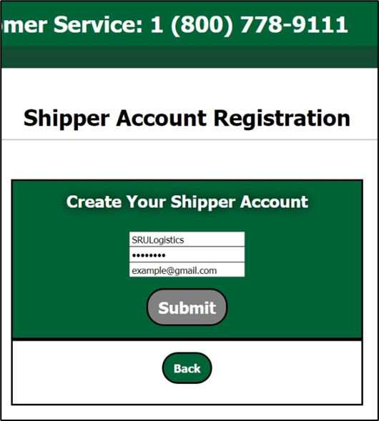

The username MUST be **at least 6 characters long and LESS THAN 32 characters**. The password MUST be **at least 8 characters long and LESS THAN 32 characters**.

An improper submission will prompt the user with an error message depending on what field was not filled in correctly.

A proper form submission will load a captcha onto the screen for the user to validate that they are not a robot (**Figure 5**). After handling the captcha, the user has created a user account with the ***SHIPPER*** role assigned to it. For further details on **Figure 4 – Shipper Registration Form** roles, see Section 2.2* **Note:** aftersuccessfully creating an account, the user will be redirected to the ***Login*** page.

**Figure 5 – Shipper Registration Form Captcha**

### 2.1.2 carrier account registration

Clicking the ***SELECT*** button under the **CARRIER** column on the ***Registration Home*** page will redirect the user to the ***Carrier Registration*** page and display the form to create a carrier account (**Figure 5**). Fields the user must provide are a ***Username, Password, Email, Carrier Name, SCAC #, Pallets, Weight, Less-Than-Truckload (LTL), and Full-Truckload (FTL)***Graphical user interface, text, application

The Username MUST be **at least 6 characters long and LESS THAN 32 characters**. The Password MUST be **at least 8 characters long and LESS THAN 32 characters**. The Carrier Name MUST not already exist in the database. The SCAC code MUST be **at least 2 characters long and NO MORE THAN 4 characters.**

An improper submission will prompt the user with an error message depending on what field was not filled in correctly.

**Figure 6 – Carrier Registration Form**

A proper form submission will prompt a captcha validation like the one seen in **Figure 5**; after navigating the captcha, a user account is created with the ***CARRIER*** role assigned to it. For further details on roles, see Section 2.2*; for further information on carriers, see Section 11*. **Note:** After successfully creating an account, the user will be redirected to the ***Login*** page.

2.2 ROLES

Every user account has a role assigned to it, and there are five roles in System: **ADMIN, SHIPPER, CARRIER, and MASTER LIST, SHADOWADMIN**.

When logged in as an admin, the roles can be viewed on the ***Users*** page (*See Section 2.3 for more details)*.

On the ***Users*** page (**Figure 8**), click the ***View Available Roles*** button to navigate to the ***Roles page*** (**Figure 7**). Here, the admin can see each user associated with each of the four available roles.

**Figure 7 – Users page with View Available Roles**

**Figure 8 – Roles Page on Admin Account**

Below is a description of each role and its unique set of permissions:

**ADMIN –** Administrator accounts are the only accounts that can change user account information. Non-admin users should contact admin users if they encounter trouble logging into their account. Administrator accounts have access to the following:

* Users (Section 2.3)
* Carrier Users (Section 2.3)
* Shipper Users (Section 2.3)
* Database (Section 15)
* Notifications (Section 14)

**SHIPPER –** Shipper accounts can create shipments that carrier accounts can then bid on. Shippers can also edit shipment details on shipments that have not yet been accepted. Shipper accounts have access to the following:

* Shipments (Section 11)
* Notifications (Section 14)

**CARRIER –** Carrier accounts have the widest range of permissions, as they interact with many of the system components. They can view and bid on the available shipments. If the bid is accepted, that shipment is assigned to the carrier account, and edit access to the shipment is granted to the carrier account. Shipments details are available for the Carrier to see. Carrier accounts have access to the following:

* **Contacts (Section 3)**
* **Carriers (Section 4)**
* **Locations (Section 5)**
* **Vehicle Types (Section 6)**
* **Vehicles (Section 7)**
* **Drivers (Section 8)**
* **Technicians (Section 9)**
* **Maintenance Orders (Section 10)**
* **Shipments (Section 11)**
* **Routes (Section 12)**
* Notifications (Section 14)
* **Auctioning (work in progress)**

**MASTER LIST –** Master List accounts have a more in-depth view of all the shipments. They can see all shipments as well as the planned shipping date(s), the assigned carrier, and even the assigned vehicle for the shipment. Master List accounts have access to the following:

* **Carriers (Section 4)**
* **Shipments (Section 11)**
* **Routes (Section 12)**
* Notifications (Section 14)

**SHADOW ADMIN –** Shadow Admin accounts have the ability to see all of the logs. This includes any changes to the database or when a user login/logout.

* **Logs (Section 13)**

**UBIQUITOUS PERMISSIONS - All** roles may access the ***Home, Login,*** and ***Registration*** pages. All roles may also log in, log out, and update their personal user details from their home screen

2.3 USERS – ADMIN ACCOUNT

***Users***: Navigates to a page displaying information for every registered user (**Figure 6**). Here, the admin can see ID numbers, usernames, emails, roles, and assigned carriers; the admin can also edit or delete users.

***Carrier Page***: Lists all current Carrier users along with their details. Ability to Edit and Delete the Carrier. Add a New User and View Available Roles.

***Shipper Page***: Lists all current Shipper users along with their details. Ability to Edit and Delete the Carrier. Add a New User and View Available Roles.

***Update User:***  Work in Progress

**Delete User:** Deletes a user, and deletes all of their dependent data to avoid ripple effects.

**Figure 9 – Admin account**

**Figure 10 – Admin Users Table**

### 2.3.1 Add user

Click the **Add a new user** to add a user.

The admin user will be redirected to a page that offers the option to add a user that either has the carrier role or a user that is a non-carrier role (**Figure 7**).

If the admin chooses to add a ***Carrier*** user, they will be redirected to a form near-identical to that seen in **Figure 5**. Alternatively, the admin may add either a ***Shipper*** or ***Admin*** account by selecting ***Other User***. Doing so will bring the admin to a form page that lets the admin add users to the system (**Figure 8**).

***Carrier Page:*** Lists just the Carriers and their details. Ability to Edit and Delete user. Can click to Add New User and View Available Roles.

***Shipper Page:*** Lists just the Shippers and their details. Ability to Edit and Delete user. Can click to Add New User and View Available Roles.

**Note:** All fields must be properly filled out for a user to be added to the system. Failing to do so will prompt a message indicating which field has the error.

**Figure 11 – Admin Add User Home Page**

**Figure 12 – Admin Add User**

### 2.3.2 update user

The admin can update a user’s email, role, and assigned carrier quite similarly to how users are added.

Simply click ***Edit User*** to be redirected to the Update User page (**Figure 9**). Here, the admin can also prompt a password reset for the user.

**Figure 13 – Admin Update User**

### 2.3.3 DELETE user

The admin can delete carrier and shipper users from database. Deleting a user deletes all of the data that is dependent on it, for example, deleting a shipper deletes all of their shipments, and all of the bids for those shipments. It also sends out notifications to any carriers/shippers whose bids or shipments were affected by the deletion. (See section 14 – Notifications)

2.4 UPDATING USER DETAILS

While an administrator has the capability to update all user account information and reset passwords, the users can also update their own emails and passwords.

After logging in, the home page will display an option ***Update User*** in the side navigation bar (**Figure 10**).

**Figure 14 – Default Home Page for Logged in User (Arrow On-Left points to Update User tab)**

Upon clicking the ***Update User*** tab, the current user will be redirected to a form where they can update their username, password, and email address.

**Figure 15 – Update-User-Details Page**

# 3. contacts

The ***Contacts*** tab redirects **CARRIER** users to a page with that carrier’s list of contacts.

The table contains the name, contact information, and geolocational information for all contacts in the carrier’s book of business (**Figure 12**).

**Figure 16 – Contacts Page for Carrier Users**

3.1 ADD CONTACT

To add a contact, Click the ***Add Contact*** Button. This will redirect the user to a form containing the following fields for a contact’s information:

* **First Name** (Ex. *John*)
* **Last Name** (Ex. Williams)
* **Middle Initial** (Ex. *R*)
* **Email** (Ex. *johnrwilliams@gmail.com*)
* **Street Address 1** First line of address (Ex. *662 Grant Street*)
* **Street Address 2** Second line of address (Ex. *Ste 3000*)
* **City** (Ex. *Las Angeles*)
* **State:** Drop down list of states
* **Zip Code** Six-digit required (Ex. *90210*)
* **Primary Phone #**  (Ex. *310-456-7890*)
* **Work Phone # (if applicable)** (Ex. *310-456-7890*)

**Figure 17 – Form for Carrier to Add a Contact**

3.2 EDIT CONTACT

To change a contact’s information, click the ***Edit*** link for that contact’s row on the table. This will redirect the user to a form identical to **Figure 12.**

**Figure 18 – Form for Carrier to Edit a Contact**

3.2 DELETE CONTACT

To delete a contact, click the ***Delete*** link in the table row of the desired contact.

The user will be redirected to a confirmation page to check that the user does indeed want to delete the contact. The contact will not be able to be deleted if it is a part of the system elsewhere.

# 4.Locations

The ***Locations*** tab lands the user on a page displaying all relevant information on locations registered to carriers in the system.

These locations may be trucking depots, fueling stations, maintenance shops, intermediate hubs, etc. **CARRIER** users can use the locations page (**Figure 17**) to view, add, edit, and delete locations associated with their account.

**Figure 19 – Locations Page for Account ‘Carrier’**

4.1 ADD LOCATION

To add a location, click the ***Add Location*** button.

The user will be redirected to a page with a form (**Figure 18**) containing the following required fields for a location:

* **Name** (Ex. *John’s Warehouse*)
* **Street Address 1** First line of address (Ex. *662 Grant Street*)
* **Street Address 2** Second line of address (Ex. *Ste 3000*)
* **City** (Ex. *Las Angeles*)
* **State:** Drop down list of states
* **Zip Code** Six-digit required (Ex. *90210*)
* **Latitude** (Ex. 40.2837465)
* **Longitude** (Ex. -83.2986357)
* **Carrier** Select the Carrier that owns the location
* **Location Type** (Ex. Warehouse, Hub, Fuel Depot)

**Figure 20 – Form to Add New Location**

4.2 EDIT LOCATION

To edit a location, click the ***Edit*** link on the ***Locations*** page data table (**Figure 17**).

The user will be redirected to a form identical to the ***Add Location*** form seen above in **Figure 18.** The user can update all the original fields entered for the location.

4.3 DELETE LOCATION

To delete a location, click the ***Delete*** link on the ***Locations*** page data table (**Figure 17**).

The user will be redirected to a confirmation page (**Figure 19**) where they can select  ***Yes*** to delete the location or ***No*** to keep the location.

If the Location is attached to another object, it cannot be deleted and gives the error: Unable to delete due to dependency conflict.

**Figure 21 – Confirmation Page to Delete Locations**

# 5.Vehicles

The ***Vehicles*** tab lands the logged in **CARRIER** user on a page displaying all relevant information on existing vehicles registered to that user (**Figure 20**).

To add a new vehicle, click the ***Add New Vehicle*** button.

**Figure 22 – Vehicles Home Page for Carrier Accounts**

5.1 ADD VEHICLE

Upon clicking the ***Add New Vehicle*** button on the Vehicles, the user will be redirected to a form page (**Figure 21**) where all relevant fields to a vehicle can be entered.

The fields are as follows:

* + **Plate Number**: Vehicle’s License Plate (Ex. - 0010)
  + **VIN Number:** Vehicle’s 17-character Vehicle Identification Number (Ex. 1G1AF1F57A7192174)
  + **Manufactured Year:** The year the vehicle was manufactured (Ex. 2020)
  + **Vehicle Type:** Choose from a list of the created Vehicle Types (Section 6)
  + **Location:** Where the vehicle is kept when not in use. Selected from a list of the created Locations (Section 4). (Ex. John’s Warehouse)
  + **Carrier:** Selected from a list of the created Carriers (Section 4). The carrier that owns the vehicle (Example: Thangiah Shipping)

**Figure 23 – From to Add a New Vehicle**

5.2 EDIT VEHICLE

To edit a vehicle’s information, click on the ***Edit*** link on the data table found on the Vehicle home page (**Figure 20**)

The user will be brought to a form page identical to the ***Add Vehicle*** form seen in **Figure 21**. Here, the **CARRIER** user can alter any/all information for the specific vehicle they choose to edit.

5.3 DELETE VEHICLE

To delete a vehicle, click on the ***Delete*** link on the data table found on the Vehicle home page (**Figure 20**).

The user will be redirected to a confirmation page much like the one seen in Section 4.3 (**Figure 19**). Simply click ***Yes*** or ***No*** to delete or keep the vehicle record.

# 6. Vehicle types

The vehicle Types tab lands the **CARRIER** user on a page (**Figure 22**) containing relevant information on the different kinds of vehicles that are registered with the system.

This page grants **CARRIER** users permissions to add, edit, and delete vehicle types on the system.

**Figure 24 – Vehicle Types Home Page**

6.1 ADD VEHICLE TYPE

To add a vehicle type, click on the ***Add New Type*** button on the data table found on the ***Vehicle Types*** home page. The user will be redirected to a form page (**Figure 23**) used to fill out all relevant information for the vehicle type.

The required fields are as follows:

* + **Type:** The main type of the vehicle (Ex. Freight Truck)
  + **Sub Type:** The sub type of the vehicle (Ex. Dual-Trailer)
  + **Description:** A brief description of the vehicle type
  + **Make:** The make of the vehicle (Example: Peterbuilt)
  + **Model:** The model of the vehicle (Example: Model 579)
  + **Minimum Weight:** The vehicle’s minimum freight weight (Example: 10,000)
  + **Maximum Weight:** The vehicle’s maximum freight weight capacity in lbs. (Example: 40,000)
  + **Capacity:** How much the vehicle can hold (Example: 3000)
  + **Maximum Range:** The maximum range vehicle type is intended for freighting (Example: 1500km)
  + **Restrictions:** Traveling restrictions for vehicle type (Ex. Maximum height for tunnels/overpasses)
  + **Height:** The vehicle’s height in feet (Ex. 12.25)
  + **Empty Weight:** The weight of the unloaded vehicle in lbs. (Ex.8000)
  + **Length:** The length of the vehicle in feet (Ex. 25.5)
  + **Minimum Cubic Weight:** The minimum cubic weight of the vehicle type (Ex. 0)
  + **Maximum Cubic Weight:** The maximum cubic weight of the vehicle type (Ex. 5000)

**Figure 25 – Form for Adding a New Vehicle Type**

6.2 EDIT VEHICLE TYPE

To edit a vehicle type’s information, click on the ***Edit*** link on the data table found on the ***Vehicle Types*** home page (**Figure 22**).

The user will be brought to a form page identical to the ***Add Vehicle*** form seen in **Figure 23**. Here, the **CARRIER** user can alter any/all information for the specific vehicle they choose to edit.

6.3 DELETE VEHICLE TYPE

To delete a vehicle type, click on the ***Delete*** link on the data table found on the ***Vehicle Types*** home page (**Figure 22**).

The user will be redirected to a confirmation page much like the one seen in Section 4.3 (**Figure 19**). Simply click ***Yes*** or ***No*** to delete or keep the vehicle type

# 7. Drivers

The ***Drivers*** tab lands the **CARRIER** user on a page displaying all relevant information/credentials on drivers registered with a specific carrier company (**Figure 24**).

**CARRIER** users can add, edit, and delete drivers on this page.

**Figure 26 – Drivers Home Page for Carrier Users**

7.1 ADD DRIVER

To add a driver, click on the ***Add Driver*** button on the data table found on the ***Drivers*** home page.

The user will be redirected to a form page (**Figure 25**) used to fill out all relevant information for the driver.

The required fields are as follows:

* + **Contact:** Selected from ***Contacts*** list (Section 3). Should match information of the ***Contacts*** record (Ex. John Williams)
  + **Carrier:** Selected from ***Carriers*** list (Section 4). This is the driver’s employer (Ex. Thangiah Shipping)
  + **Vehicle:** Selected from ***Vehicles*** list (Section 7). This is the vehicle the driver drives.
  + **License Number:** The driver’s driver license number (Example: 25 624 867)
  + **License Expiration:** The expiration date of the driver’s license (Example: 05/16/2026)
  + **License Class:** The class of the driver’s license (Example: C)

**Figure 27 – Form for Carriers to Add Drivers**

7.2 EDIT DRIVER

To edit a driver’s information, click on the ***Edit*** link on the data table found on the ***Drivers*** home page (**Figure 24**)

The user will be brought to a form page identical to the ***Add Driver*** form seen in **Figure 25**. Here, the **CARRIER** user can alter any/all information for the specific driver they choose to edit.

7.3 DELETE DRIVER

To delete a driver, click on the ***Delete*** link on the data table found on the ***Drivers*** home page (**Figure 24**).

The user will be redirected to a confirmation page much like the one seen in Section 4.3 (**Figure 19**). Simply click ***Yes*** or ***No*** to delete or keep the driver

# 8. Technicians

The ***Technicians*** tab lands the **CARRIER** user on a page displaying all relevant information/credentials on technicians registered with a specific carrier company (**Figure 26**).

**CARRIER** users can add, edit, and delete technicians on this page.

**Figure 28 – Technicians Home Page for Carriers**

8.1 ADD TECHNICIAN

To add a technician, click on the ***Add Technician*** button on the data table found on the ***Technicians*** home page.

The user will be redirected to a form page (**Figure 27**) used to fill out all relevant information for the technician.

The required fields are as follows:

* **Contact:** Chosen from the ***Contacts*** list (Section 3). This is the technician the user is adding. (Ex. John Williams)
* **Skill Grade:** A grade indicating level of proficiency for the technician (Ex. B)

**Figure 29 – Form for Carriers to Add Technicians**

8.2 EDIT TECHNICIAN

To edit a technician’s information, click on the ***Edit*** link on the data table found on the ***Technicians*** home page (**Figure 26**)

The user will be brought to a form page identical to the ***Add Technician*** form seen in **Figure 27**. Here, the **CARRIER** user can alter any/all information for the specific technician they choose to edit.

8.3 DELETE TECHNICIAN

To delete a technician, click on the ***Delete*** link on the data table found on the ***Technicians*** home page (**Figure 24**).

The user will be redirected to a confirmation page much like the one seen in Section 4.3 (**Figure 19**).

Simply click ***Yes*** or ***No*** to delete or keep the technician.

# 9. Maintenance orders

The ***Maintenance*** tab lands the **CARRIER** user on a page displaying all relevant information on maintenance orders submitted by the user’s carrier company (**Figure 28**).

**CARRIER** users can add, edit, and delete maintenance orders on this page.

**Figure 30 – Maintenance Order Home Page for Carriers**

9.1 ADD MAINTENANCE ORDER

To add a maintenance order, click on the ***Add New Order*** button on the data table found on the ***Maintenance Orders*** home page.

The user will be redirected to a form page (**Figure 29**) used to fill out all relevant information for the maintenance order.

The required fields are as follows:

* **Technician:** The technician assigned to the order (Ex. John Walker)
* **Scheduled Date:** The date maintenance is to take place (Ex. 07/13/2022)
* **Details:** A description of the item to be completed (Ex. Battery Replacement)
* **Service Type:** Valid service types are repair, maintenance, replace, etc.
* **Cost:** Quote for total cost (parts & labor) of the job (Ex. $4995.99)
* **Status:** Whether the job is either ***Pending*** or ***Completed***
* **Vehicle:** The specific vehicle requiring maintenance
* **Maintenance Type:** A general description of the location of maintenance being performed (Ex. Engine)

**Figure 31 – Form for Carriers to Submit Maintenance Orders**

9.2 EDIT MAINTENANCE ORDER

To edit a maintenance order’s information, click on the ***Edit*** link on the data table found on the ***Maintenance Order*** home page (**Figure 26**)

The user will be brought to a form page identical to the ***Add New Order*** form seen in **Figure 29**. Here, the **CARRIER** user can alter any/all information for the specific Maintenance Order they choose to edit.

9.3 DELETE MAINTENANCE ORDER

To delete a maintenance order, click on the ***Delete*** link on the data table found on the ***Maintenance Order*** home page (**Figure 24**).

The user will be redirected to a confirmation page much like the one seen in Section 4.3 (**Figure 19**).

Simply click ***Yes*** or ***No*** to delete or keep the maintenance order.

# 10. Carriers

The ***Carriers*** tab show all relevant (depends on user type) information on carriers that are registered in the system.

It is accessible by **MASTER LIST** and **CARRIER** users.

The view for Master List accounts includes all carriers and their information (**Figure 17**).

Carrier accounts can edit their own carrier information. (**Figure 18**).

**Figure 32 – Carriers Table (Master List View)**

**Figure 33 – Carriers Table (Carrier View)**

10.1 DETAILS ON ADDING CARRIERS

**CARRIER** users are only created through registering a **CARRIER** account with the process detailed in Section 2.2. Upon successful creation of a **CARRIER** account, the carrier-specific information fields will appear in the Master List view of the Carriers table (**Figure 30**) in the ***Carriers*** list. The carrier fields are as follows:

* **Carrier Name:** The name of the carrier company (Example: *Thangiah Shipping*)
* **SCAC:** The 2-4 character Standard Carrier Alpha Code; each carrier has one (Example: *GZBO*)
* **LTL:** Indicates if carrier is capable of Less Than Truckload shipping (Example: *Yes*)
* **FTL:** Indicates if carrier is capable of Full Truckload shipping (Example: *Yes*)
* **Pallets:** The maximum number of pallets that a carrier’s largest vehicle type can ship at once (Example: *125*)

10.2 EDIT CARRIER

**CARRIER** users are permitted to edit their own carrier information. To edit carrier information, click the ***Edit*** link in the carrier table on the ***Carriers*** page. The user will be redirected to a form (**Figure 19**) where they can alter all carrier fields.

**Figure 34 – Form for Updating Carriers**

# 11. Shipments and bids

The ***Shipments*** tab is available to **CARRIER**, **SHIPPER**,and **MASTER LIST** users.

Shipments are the key component of the logistics pipeline in the System that shippers create for carriers to bid on for the purpose of handling commerce.

Upon clicking the ***Shipments*** tab, all users are taken to a page where they can choose between ***Available Shipments*** and ***Accepted Shipments*** (**Figure 33**). The differences between role access as well as the bidding system are detailed in the following subsections.

**Figure 35 – Shipments Home Page for a Carrier Account – Page Content is Identical for Other Roles with Different Tabs on Navigation Bar**

11.1 SHIPMENTS - OVERVIEW

Shipments are accessible to varying degrees by the **SHIPPER**, **CARRIER**, and **MASTER LIST** roles.

Each role’s ***Available Shipments*** and ***Accepted Shipments*** pages displays a different subset of shipment information.

The exhaustive list of shipment attributes is as follows:

* **ID:** System identification number of the shipment (Ex. 5)
* **Client:** The shipper entity commerce is being shipped for by the carrier. (Ex. Marrakesh Shipping)
* **Carrier:** The carrier who has accepted the freighting job of a shipment (Ex. Thangiah Logistics)
* **SCAC:** The 2–4-character Standard Carrier Alpha Code (Ex. 5ATS)
* **Client Mode:** Whether the client requires FTL or LTL for the shipment
* **Ship Date:** The scheduled date of the shipment (Ex. 07/15/2023)
* **Freight Bill Number:** The number identifying the invoice document of the freight (Ex. 2331516178)
* **Paid Amount:** The accepted bid price for the shipment (Ex. $999.99)
* **Full Freight Terms:** Status on if shipment is ***Available*** or ***Accepted***
* **Commodity Class:** Class of the commodities being shipped (Ex. 12)
* **Commodity Pieces:** Number of pieces being shipped (Ex. 500)
* **Commodity Paid Weight:** Weight of the shipment (Ex. 7500)
* **Shipper City:** Starting city commerce is being shipped from (Ex. Cincinnati)
* **Shipper State:** Starting state commerce is being shipped from (Ex. OH)
* **Shipper Zip:**  Starting zip code commerce is being shipped from (Ex. 23066)
* **Shipper Latitude:** Starting Latitude (Ex. 40.2828211)
* **Shipper Longitude:** Starting Longitude (Ex. -79.4649991)
* **Consignee City:** Destination city commerce is being shipped to (Ex. Scranton)
* **Consignee State:** Destination state commerce is being shipped to (Ex. PA)
* **Consignee Zip:** Destination zip code commerce is being shipped to (Ex. 19202)
* **Consignee Latitude:** Destination latitude (Ex. 40.9779662)
* **Consignee Longitude:** Destination longitude (Ex. -80.6754588)

11.2 SHIPMENTS - SHIPPER

The **SHIPPER** accounts are the accounts that create shipments.

**The SHIPPER** role’s interactions with shipments are discussed below.

The Shipments main page (**Figure 34**) allows the shipper to select shipments by their ***status***:

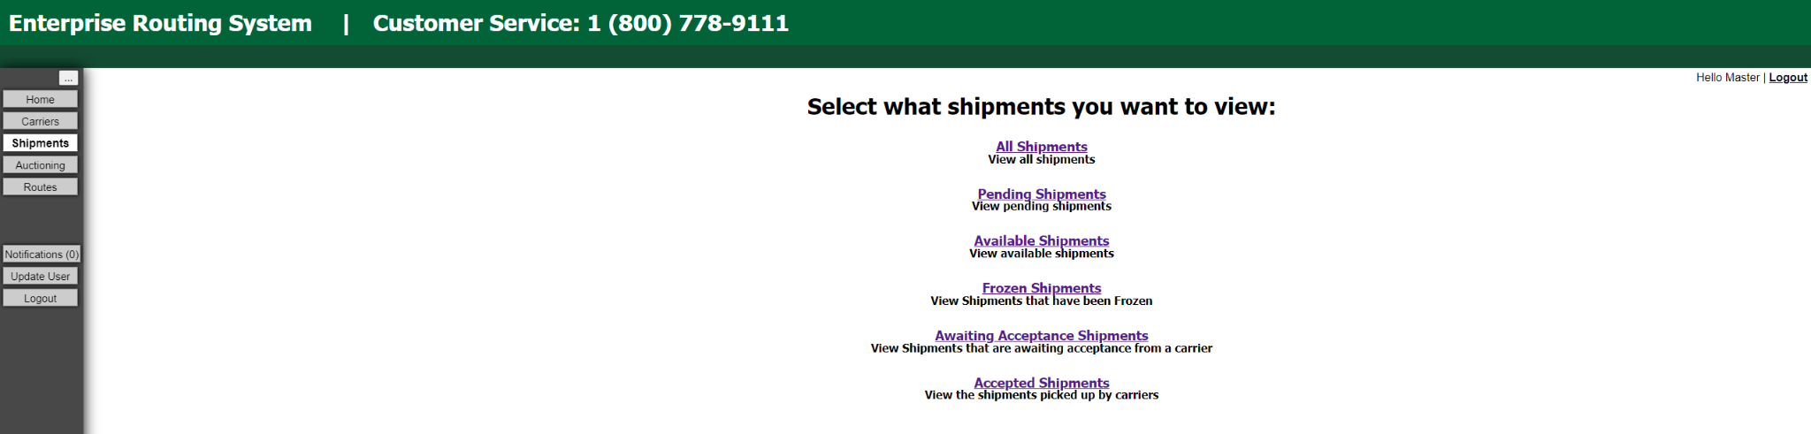

**Figure 36 – Shipper account Shipments Main page**

### 11.2.1 All Shipments - SHIPPER

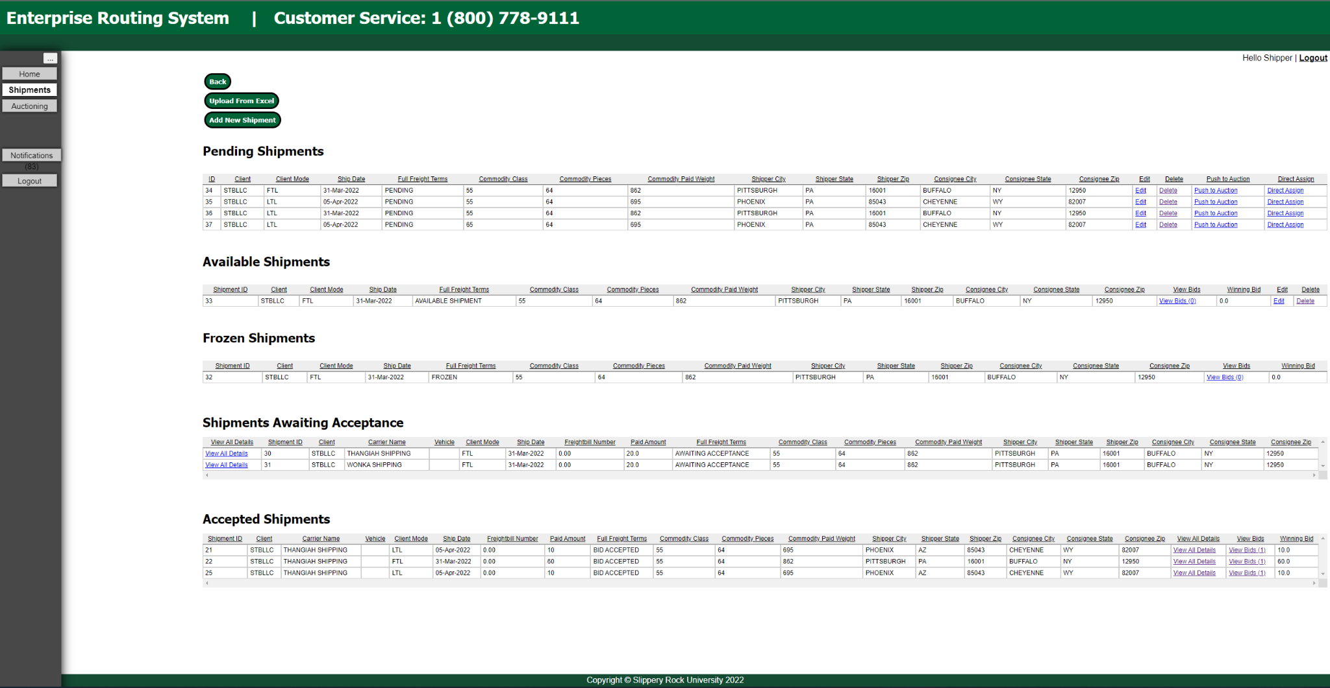

Figure 54 - SHIPPER view of All Shipments Page

***All Shipments:*** Interfaces with all shipment types for the roles ***SHIPPER, CARRIER, MASTER*** (Figure 54). This displays differently depending on the role. For ***SHIPPER*** this displays all of the shippers OWN shipments. For ***MASTER*** this displays all of every shipment. For ***CARRIER***  this displays all of the Available Shipments and all of the users own Accepted shipments.

### 11.2.2 Pending Shipments - SHIPPER

***Pending Shipments:*** Interfaces with a list of shipments in Pending status. These are the shipments that have been created but not yet ***Pushed into Auction.*** (**Figure 35**)

* New Shipments can be created by clicking the ***Add New Shipment*** button. It will redirect the user to the ***Add Shipment*** form page (**Figure 36**) where the shipment information can be entered.
* The user can edit that information by clicking the ***Edit*** link in the row of the desired shipment. The link redirects the user to the ***Update Shipment*** page (**Figure 37**) where all information fields can be edited.
* The user can also ***Upload an Excel File*** to fill in the information. (Detailed in 11.2.3)
* The user can auction the shipment by clicking the ***Push to* Auction** button. It will move the shipment to the Created shipments state (See below)
* The user can also bypass the auction and directly assign a shipment to a carrier by clicking the ***Direct Assign*** Button. It will redirect users to the ***Direct Assign Shipment*** *(***Figure 38.5***)*page where a carrier can be selected and a price can be entered. This will send a notification and an email to the carrier, who can then accept or deny the request to take the shipment. The price can also be assigned based on the shippers **Freight Rate Table** if one has been uploaded. To assign the price from the freight rate table, simply click the “assign from freight rate table” button next to the price input bar. (See section 17 – Freight Rate Table)

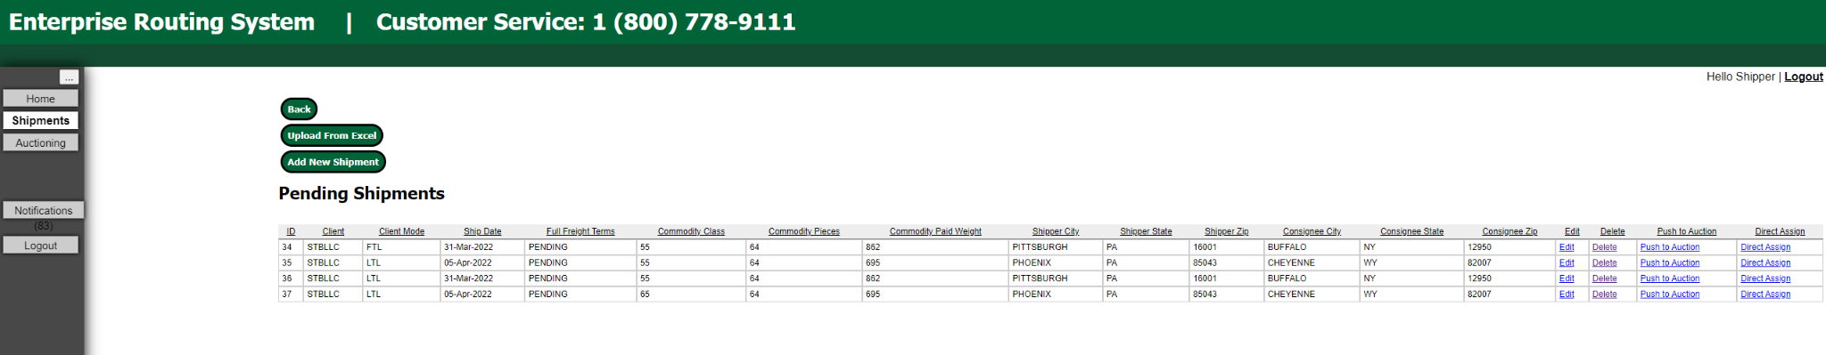

**Figure 35 – Shipper View of the** Pending **Shipments Page**

**Figure 37 – Form to Add a New Shipment**

**Figure 38– Form to Update an Existing Shipment**

**Figure (38.5)– Form to directly assign shipment to carrier**

### 11.2.3 Upload Excel File – Shipper

The **SHIPPER** user can also click the ***Upload an Excel File*** button on the ***Pending Shipments*** page to navigate to a page (**Figure 38**) that allows multiple shipments to be uploaded in the form of a csv file. **NOTE:** The csv **MUST** be in the **EXACT** format given in the template file.

**Figure 39 – Shipper Page to Upload CSV Files**

### 11.2.4 Pending Shipments – SHIPPER

**Pending Shipments**: Here, the shipper may add new shipments, or upload new shipments from an existing excel file. Once they are uploaded, they can be pushed to auction by clicking the “push to auction” button, which will move the shipments from pending to Available. (see Next Section)

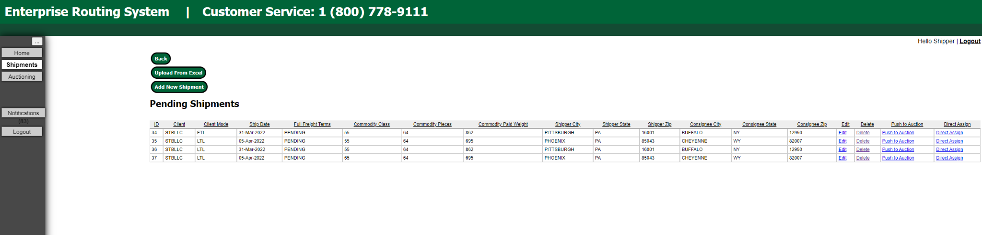

**Figure 39.5 – Pending Shipments**

### 11.2.5 Available/created sHIPMENTS – Shipper

***Available Shipments:*** Interfaces with the list of shipments in Available status. These are the shipments that are currently up for auction. Here, the shipper can View the bids on the shipment and accept them. Can also Edit and Delete the shipments.

Here, the **SHIPPER** role has the capability to view and accept bids placed by **CARRIER** users. Clicking the ***View Bids*** link will redirect the user to the ***Bids***page (**Figure 41**) for the selected shipment. The current number of bids is displayed in parentheses next to the view bids tab, as well as the current winning bid (lowest). More details about the bidding system are found in Section 11.2.6.

The shipper may also ***Remove From Auction***a shipment by clicking the remove from auction button. This will delete all bids on the shipment and return it to Pending Shipments

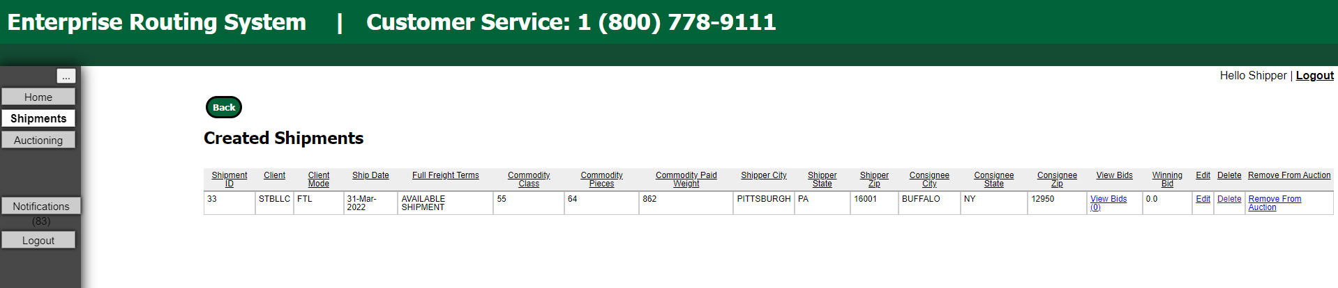

**Figure 40 – Shipper view of Available Shipments**

### 11.2.6 Frozen Shipments – SHIPPER

***Frozen Shipments:*** Interfaces with the list of shipments in Frozen status. Frozen shipments can only be interacted with by the Master

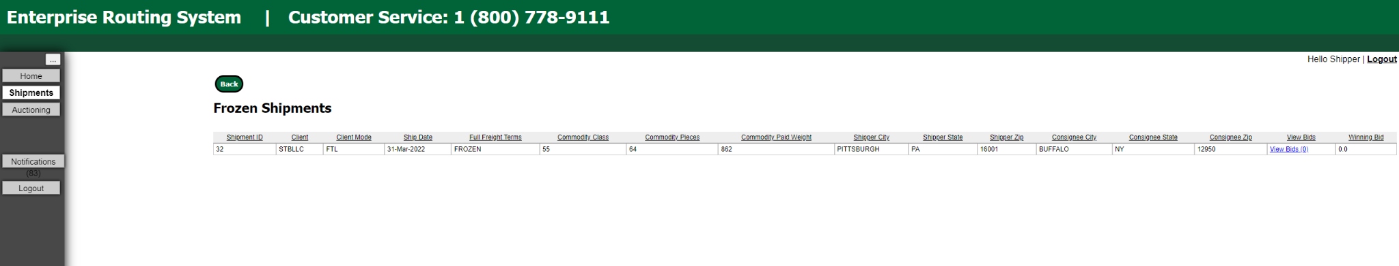

**Figure 41 – Shipper view of Frozen Shipments**

### 11.2.7 Accepted Shipments – SHIPPER

***Accepted Shipments:*** Interfaces with the list of shipments in Accepted status. These are shipments after bids have been accepted and are ready to be shipped. The shipment details can be viewed as well as the bid history.

The **SHIPPER** account view of the ***Accepted Shipments*** page (**Figure 40)** displays a table containing that user’s shipment records with associated information. The fields *Carrier Name, Vehicle, Freightbill Number, Full Freight Terms,* and *Paid Amount* are additions to the ***Created Shipments*** page and come from the **CARRIER** account associated with accepting the shipment. More details are available in Section 11.3.

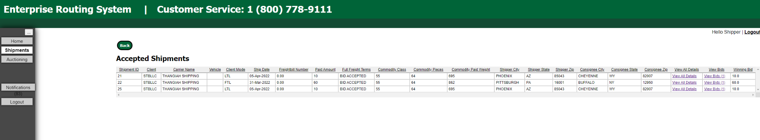

**Figure 42 – Shipper View of the Accepted Shipments Page**

### 11.2.8 Awaiting Acceptence Shipments – SHIPPER

***Awaiting Acceptance Shipments:* Interfaces with the list of shipments that are waiting to be accepted by a carrier from the direct assignment screen. Only carriers can approve or deny on this page**

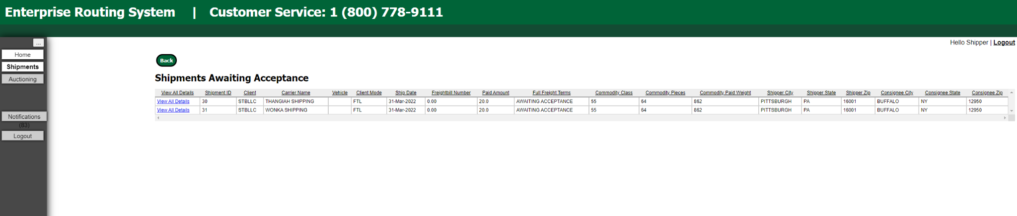

### 11.2.9 View / Accept bids – SHIPPER

**SHIPPER** users are responsible for accepting bids placed on shipments by **CARRIER** users. The user does this by clicking on the ***View Bids*** link found on the ***Available Shipments*** page (**Figure 38**).

The user will be redirected to the ***Bids*** page (**Figure 41**), where they can see all bids that have been placed on the shipment.

Clicking ***Accept Bid*** will grant the shipping job to the carrier who placed the bid at the price of the bid, and it will move the shipment to the ***Accepted Shipments*** page. Each bid contains the following information:

* **Shipment ID:** ID attached to the shipment
* **Price:** Bid amount
* **Date:** Date bid was placed
* **Time:** Time bid was placed
* **Bidder: CARRIER** account that placed the bid

**Figure 43 – Shipper View of Bids Page**

11.3 SHIPMENTS - CARRIER

The **CARRIER** accounts are the accounts that bid on shipments. They are responsible for freighting the shipments from source to destination. The interactions **CARRIER** accounts have with shipments are detailed below.

### 11.3.1 Created Shipment - CARRIER

The **CARRIER** account view of the ***Available Shipments*** page (**Figure 40**) displays a table containing that user’s shipment records with associated information. Here, the user can view all bids on a pending shipment or add a bid on one themselves.

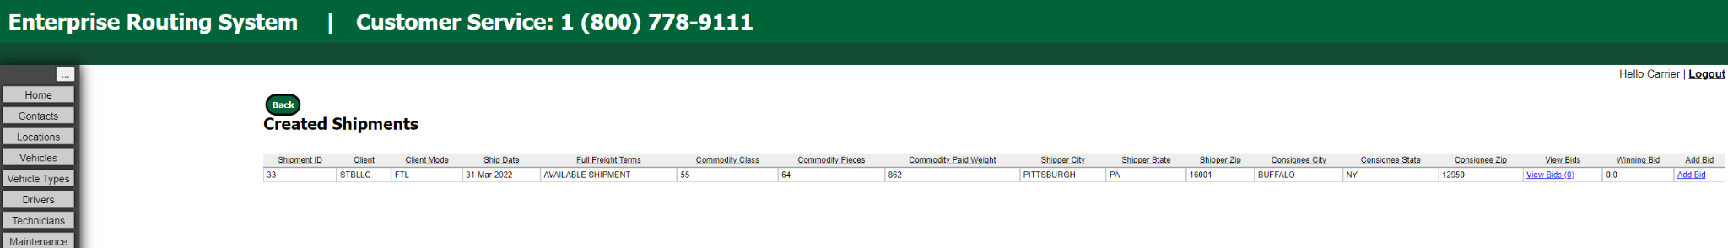The user can edit that information by clicking the ***Edit*** link in the row of the desired shipment. The link redirects the user to the ***Update Shipment*** page (**Figure 36**) where all information fields can be edited.

**Figure 43 – Carrier View of the Created Shipments Page**

### 11.3.2 Place/Edit Bids - CARRIER

The **CARRIER** user can place bids on shipments by clicking the ***Add Bid*** link. It will redirect the user to the ***Add Bid*** form page (**Figure 41**) from the Available Shipments pagewhere the bid price can be entered.

**Figure 44 – Form to Add a Bid**

The user can edit that information by clicking ***View Bids*** and then ***Edit*** link in the row of the desired shipment on the ***Available Shipments*** *page (***Figure 42***)*. The link redirects the user to the ***Update Bid*** page (**Figure 42**) where the bid price and shipment information can be edited.

**Figure 45 – Form to Edit a Bid**

### 11.3.3 Accepted Shipment – CARRIER

The **CARRIER** account view of the ***Accepted Shipments*** page (**Figure 43**) displays a table containing that user’s accepted shipment records associated with that account. These are the jobs the carrier company has accepted. On this page, the user can view and edit the shipment details.

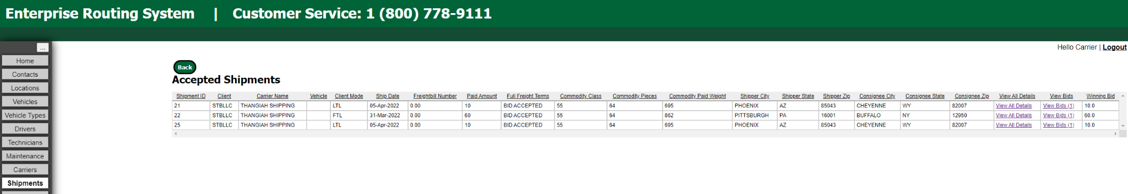

**Figure 46 – Carrier View of Accepted Shipments for that Carrier**

To view the details of a shipment, click the ***View All Details*** link on the ***Accepted Shipments*** page (**Figure 43**). The user will be redirected to a page detailing all aspects of the shipment (**Figure 44**). It also includes Google Maps links to both locations by coordinates as well as the route between locations (*At Page Bottom*).

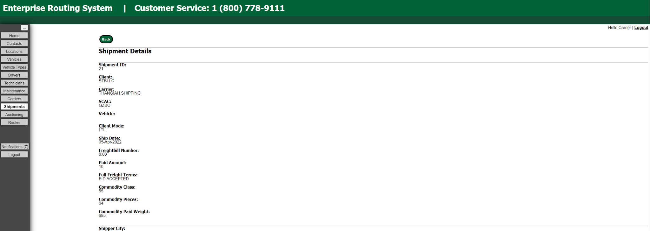

**Figure 47 – Carrier View of Shipment Details**

### 11.3.4 Awaiting Acceptance Shipment – CARRIER

**Carriers** are responsible for accepting or denying shipments that are direct assigned to them by shippers. Carriers will receive an email when a shipment is awaiting direct assignment. Carriers can click accept or deny for shipments in the ***Shipments awaiting Acceptance screen (Fig 47.5)***

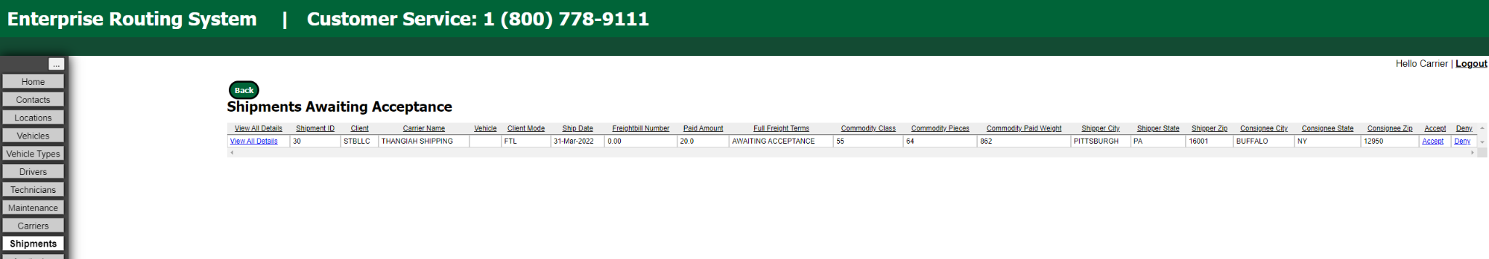

***Fig 47.5 - The Shipments awaiting acceptance screen***

11.4 SHIPMENTS – MASTER LIST

The **MASTER LIST** role can view and manipulate the following in Shipments:

***Pending Shipments*** is a list of all shipments pending in the system regardless of what shipper created the shipment. Ability to Edit, Delete, Freeze, and Push the shipment to auction.

**Figure 48 – Master View of Pending Shipments**

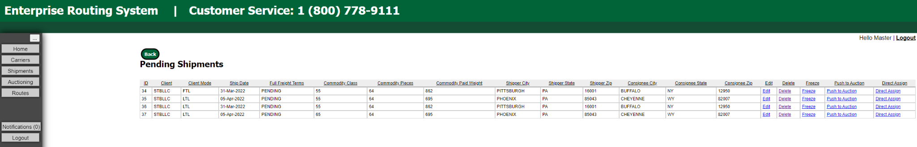

***Available Shipments*** lists the shipments in auction. Ability to do the following:

* **View Bids**: view all bids for all shipments in auction.
* **Reset Bids:** Deletes all bids for the shipment.
* **Edit:** (WORK IN PROGRESS)
* **Delete:** Delete the shipment.
* **Freeze:** Suspends the shipment from being in auction until **MASTER** user unfreezes it.
* **Force End Auction:** Forces the auction to end. The lowest bidder is assigned the shipment. Application

  Description automatically generated with low confidence

**Figure 49 – Master View of Available Shipments**

***Frozen Shipments*** lists the shipments that are currently Frozen. Ability to View and Reset Bids, Edit, Delete and Unfreeze shipments. *If a shipment is put int a Freeze, it no longer shows in the auction.

* **View Bids:** view all bids for all shipments in auction.
* **Edit:** (WORK IN PROGRESS)
* **Unfreeze:** Unfreeze the shipments that were in frozen status
* **Reset Bids:** Delete all bids for a shipment in auction. Application, table, Word

  Description automatically generated with medium confidence

**Figure 50 – Master View of Frozen Shipments**

***Accepted Shipments*** page is a list of all shipments accepted by all carriers. shipment details and bids, Edit (work in progress), Delete shipment, and Reset Bids.

* **View All Details:** Shipment Details page is displayed.
* **View Bids**: view all bids for all shipments in auction.
* **Edit:** (WORK IN PROGRESS)
* **Delete:** Delete the shipment.
* **Reset Bids:** Deletes all bids for the shipment.

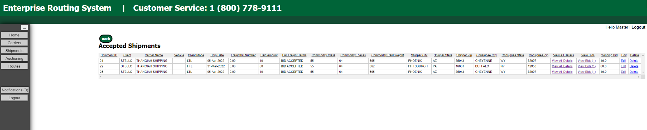

**Figure 51 – Master View of Accepted Shipments**

# 12. Routes

The ***Routes*** tab is available to **CARRIER** and **MASTER LIST** user accounts to manage shipments associated with specific vehicles and specific dates/times. Both roles can display scheduled shipments for the vehicle in aggregate, if the vehicle has numerous, upcoming shipments (**Figure 49**).

**Figure 52 – Routes Page**

# 13. Logs

The ***Logs*** tab is available to **SHADOW ADMIN** user accounts. The purpose of this page is to display all of the logs to the user. The logs include when the database is manipulated and when a user login/logout.

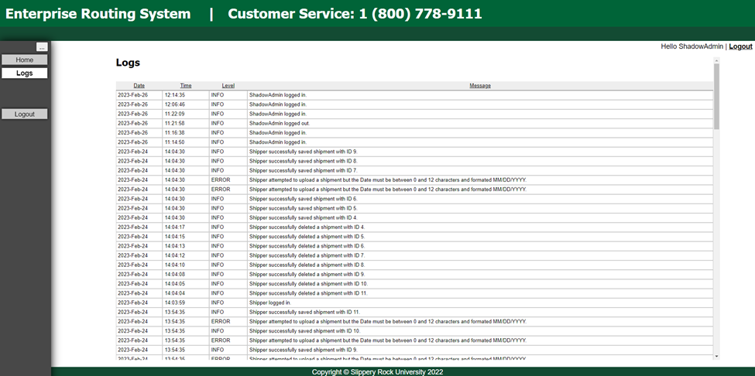

**Figure 53 – Logs Page**

# 14. Notifications

The **Notifications** tab is available to all user roles except ShadowAdmin. Users receive notifications whenever one of their database elements is altered by a user other than themselves. For example, when the Master deletes a shipper’s shipment, the shipper receives a notification indicating it has been deleted, and so do all carriers who had bids on it.

**Figure 54 – Notifications Page**

Notifications can be marked as read or unread, or all unread notifications can be marked as read at once. The amount of *unread* notifications the user currently has is displayed in parentheses next to the notification button on all screens.

# 15. Database

Admins may at any time reset the database to a backup from the **Database** screen. Backups are performed every twenty minutes and are saved to webrouting/backups. Backups are labeled with their data and time in the filename in following format: “backup MM_DD_YYYY_hh_mm.sql”

Be aware that resetting the database to a backup drops the current contents of the database.

**Figure 55 – Database Page**

# 16. EXCEL UPLOADIng

**Carriers can upload the following entities via excel: *Contacts, Locations, Vehicles, Vehicle Types, Drivers, Technicians, Maintenance Orders*. This can be done by clicking the “Upload From Excel” button at the top of each entities page. See Figure 56 below.**

**Figure 56 – Upload From Excel button**

**In order to avoid dependency conflicts with various fields a carrier must upload their documents in the following order:**

1. **Contacts**
2. **Locations**
3. **Vehicle Types**
4. **Vehicles**
5. **Drivers**
6. **Technicians**
7. **Maintenance Orders**

**When uploading via excel, each entity has a different template that must be followed. A carrier can receive each template at the top of the various upload pages See figure 57 below.**

**Figure 57 – Download Template**

# 17. Freight rate tables

**Shippers may upload a freight rate table by clicking on the update user button on the sidebar, and then selecting the “Upload Freight rate table” button (Fig 58).**

**Freight Rate Tables must match the format shown in Fig 59. The weight row at the top contains the breakpoint weights for shipments. IE, if your breakpoint weights are <500 and <1000, a shipment with a weight of 800 will fall into the <1000 column. The class row on the left side contains the shipment class. So, in the example table in Fig. 59, a shipment with a class of 60 and a weight of 100 pounds would have a default price of $160.**

**Figure 58 – The freight rate table uploading menu**

**Figure 59 – A valid freight rate table**

# 18. Figures

**Figure 1 – Home Page of System (Content-Push Nav-Bar Open) 4**

**Figure 2 – Home Page of System (Content-Push Nav-Bar Closed) 4**

**Figure 3 – Registration Home Page 5**

**Figure 4 – Shipper Registration Form 6**

**Figure 5 – Shipper Registration Form Captcha 6**

**Figure 6 – Carrier Registration Form 7**

**Figure 7 – User Page 8**

**Figure 8 –Admin Account Tabs 9**

**Figure 9 - Admin Users Table 9**

**Figure 10 – Admin Add User Home Page 10**

**Figure 11 – Form for Admin to Add User 12**

**Figure 12 – Form for Admin to Update User 12**

**Figure 13 – Default Home Page for Logged in User 13**

**Figure 14 – Update-User-Details Page for 13**

**Figure 15 – Contacts Page for Carrier Users 14**

**Figure 16 – Form for Carrier to Add a Contact 15**

**Figure 17 – Form for Carrier to Edit a Contact 16**

**Figure 18 – Locations Page for Carrier Account 17**

**Figure 19 – Form to Add New Location 18**

**Figure 20 – Confirmation Page to Delete Locations 18**

**Figure 21 – Vehicles Home Page for Carrier Accounts 19**

**Figure 22 – Form to Add a New Vehicle 20**

**Figure 23 – Vehicle Types Home Page 21**

**Figure 24 – Form for Adding a New Vehicle Type 22**

**Figure 25 – Drivers Home Page for Carrier Users 23**

**Figure 26 – Form for Carriers to Add Drivers 24**

**Figure 27 – Technicians Home Page for Carriers 25**

**Figure 28 – Maintenance Order Home Page for Carriers 26**

**Figure 29 – Form for Carriers to Submit Maintenance Orders 27**

**Figure 30 – Carriers Table (Master List View) 28**

**Figure 31 – Carriers Table (Carrier View) 28**

**Figure 32 – Form for Updating Carriers 29**

**Figure 33 - Shipments Home Page for a Carrier Account 30**

**Figure 34 – Shipper account Shipments Main Page 31**

**Figure 35 – Shipper View of the Pending Shipments Page 31**

**Figure 36 – Form to Add a New Shipment 32**

**Figure 37 – Form to Update an Existing Shipment 32**

**Figure 38 – Shipper Page to Upload CSV Files 33**

**Figure 39 – Shipper View of the Available Shipments Page 33**

**Figure 40 – Shipper View of Frozen Shipments 34**

**Figure 41 – Shipper View of the Accepted Shipments Page 34**

**Figure 42 – Shipper View of Bids Page 35**

**Figure 43 - Carrier View of the Create Shipments Page 35**

**Figure 44 - Form to Add a Bid 36**

**Figure 45 - Form to Edit a Bid 36**

**Figure 46 – Carrier View of Accepted Shipments for that Carrier 37**

**Figure 47 - Carrier View of Shipment Details 38**

**Figure 48 - Carrier View of Pending Shipments 38**

**Figure 49 – Master View of Available Shipments 39**

**Figure 50 – Master View of Frozen Shipments 39**

**Figure 51 - Master View of Accepted Shipments 40**

**Figure 52 - Routes Page 40**

**Figure 53 - Logs Page 41**

**Figure 54 - Shipper View of All Shipments 32**

**Figure 55 – Database Page 47**

**Figure 56 – Upload From Excel button 48**

**Figure 57 – Download Template 48**